1. What is collection of framework in java?

* Basically is nothing but combination of classes and interface that implement commonly reusable collection data structures.
* Also collection of framework allow us to manipulated and store group of object.
* Collection interface and classes are present in java.util.pacakge.

1. What are major interface in java?

* The major interface of collection framework is set, map, list, queue and those major four interface internally extends to collection interface and this collection interface internally also extends to Iterable interface, that’s how the hierarchy interface in java
* Now as we know that when we have a interface they should be corresponding implementation class, that mean a class which will implement the method of interface
* Bellow diagram:

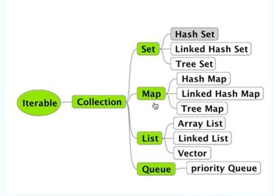

1. From above diagram a List interface has been implement three classes Arraylist, LinkList and vector
2. What is ArrayList in java?

* Array list help us to store group of object data
* Array list size will grow dynamically and array list uses dynamic array
* Array list store data which is based on the index
* Array list also allow us to store duplicate data
* When I do not write any kind of data type in array list, I can store any kinds of data
* Object is the super classes all the classes in java

1. What is linked list?

* Linked list also allow us to store any kind of data similar to array list

1. What is the main difference between Array list and Linked list?

* Basically main difference between of them is architecture of classes, if we look at diagram

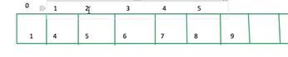

Array List

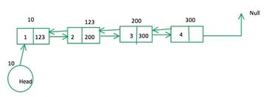

Linked List

* Array list store data based on index, so whenever data will increment in the same time size of array will grow in dynamic.
* Manipulation array list is slow because If I remove data from index 2 the array list internally it will rearrange, as we know that 4 will become 3 and 5 will become 4, so that means shifting is happening , this is the reason of manipulation is slow in array list
* Array list is better for sorting and accessing data
* Linked list data will store based on node concept, so how does work linked list, in case of linked list head node will be pointing to the first node, first node will point the second node and second node has two reference , by one reference we can go backward and second reference we can go forward, so here head node is 10 so this 10 will be address of the first node, also in first address we have two section, first is data and second is address of second node, so 123 is second node and similar to it has two section which first is data and second is address of third node
* In case of linked list when we remove the node, let say I want to remove node number 2, so here no internal shifting only reference has shifted. That’s why manipulation is faster in linked list.
* Deletion in linked list is slow

1. What is vector in java?

* Vector also has same methods similar to array list and linked list, but Vector is the thread safe, when I say vector is thread safe what does mean, when multiple thread will try to utilize the resource of vector class, data corruption will not happen, but array list and linked list is not safe.

1. What is the purpose of Iterator in java?

* The purpose of Iterator is to iterate the collection of data, assume that we have an array list and we want to iterate all the data or retrieve the data, or we want to print, so how can do that, Iterator is basically interface and it has 3 methods, hasNext(), next(), and remove(), so hasNext() will check weather is any data in collection of object, next() will return the data and pointer to the next element and remove() will remove the data from the collection of object.
* This will work for array list and linked list

1. What is list iterator in java?

* List iterator is similar to iterator, it has some additional methods
* help us to store group of object data

1. What is the purpose of HashSet in java?

* Hashset is similar to arraylist and linked list
* help us to store group of object data
* But in hashset we cannot store duplicate element, but it was possible to array list and linked list
* But second thing is hashSet cannot maintain insertion order. But all the list classes main insertion rule
* We can add one set of class data to another set of class data but in case of hashSet both set will be unique of data
* We cannot store the data based on the index in case of hashSet

1. What is main difference between hasSet and LinkedHasSet in java?

* In case of same methods in hasSet and LinkdedSet but there is main difference is linkedHasSet maintain insertion order where is hasSet do not maintain insertion order
* So when we want to maintain insertion order and duplicate data that time we can use to linkedHasSet

1. What is the main difference between linkedHasSet and treeSet in java?

* Tree set maintain insertion in ascending order as usual as maintain duplicate data